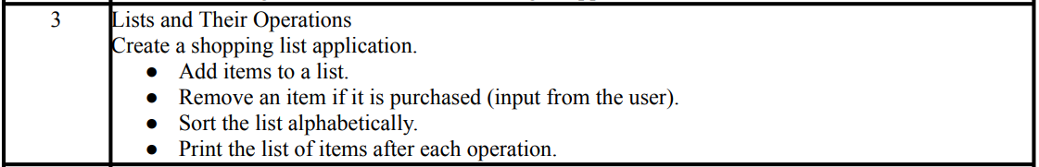
==================================================================================
COMMAND:
"""Lists and Their Operations
Create a shopping list application.
● Add items to a list.
● Remove an item if it is purchased (input from the user).
● Sort the list alphabetically.
● Print the list of items after each operation.
"""

# Create an empty shopping list
shopping_list = []

while True:
print("\nShopping List Menu:")
print("1. Add item")
print("2. Remove item")
print("3. Sort list")
print("4. Show list")
print("5. Exit")

choice = input("Enter your choice (1-5): ")

if choice == "1":
item = input("Enter item to add: ")
shopping_list.append(item)
print("Item added.")
print("Current list:", shopping_list)

elif choice == "2":
item = input("Enter item to remove: ")
if item in shopping_list:
shopping_list.remove(item)
print("Item removed.")
else:
print("Item not found in the list.")
print("Current list:", shopping_list)

elif choice == "3":
shopping_list.sort()
print("List sorted alphabetically.")
print("Current list:", shopping_list)

elif choice == "4":
print("Shopping list:", shopping_list)

elif choice == "5":
print("Exiting... Goodbye!")
break

else:
print("Invalid choice. Please enter a number from 1 to 5.")

OUTPUT:

